Running the Sotomayor tutorial

using Childers’ Windows GT installation package
Authors: Linh Ngo and Amy Apon, April, 2006

This tutorial illustrates the steps of doing the Sotomayor tutorial on your own Windows computer. The complete tutorial should be referenced, and can be found online at (Chapter 3: Writing your First Stateful Web Service in 5 Easy Steps).

You will need to access:

http://gdp.globus.org/gt4-tutorial/singlehtml/progtutorial_0.2.1.html#chap_core_first

and follow the steps in it. There is one preliminary step.

Step 0: Setting up the environment

- Install Jakarta ant 1.5 or 1.6 from www.ant.apache.org

- Install Java 1.4.2 (recommended) or 1.5

- Install Python 2.4.3 for Windows from http://www.python.org/download/

- Create a folder in your C:\ directory called tutorial

One way to do this is to Go to Start/Run, types in command “cmd” to open a Windows command console.
$ cd C:\
$ mkdir C:\tutorial
$ cd C:\tutorial

- Download the windows GT install package from
http://www-unix.mcs.anl.gov/~childers/tutorials/BAS/GPN/gt-install.zip
to the C:\tutorial folder.

(See
http://www-unix.mcs.anl.gov/~childers/tutorials/BAS/GPN/ for the full web page on this.)

- Download Sotomayor tutorial example source code and supporting files from
http://gdp.globus.org/gt4-tutorial/download/progtutorial-examples_0.2.1.tar.gz
to the C:\tutorial folder.

See http://gdp.globus.org/gt4-tutorial/ for the starting web page on this.)

- Open two Windows command consoles. You can do this by opening another window by going to to Start/Run and typing in command “cmd” to open a Windows command console.
Let’s call these two windows the GT window and the Exercise window.

- On the GT Window, to set up Globus, follow Childers’ instructions:
Unzip gt-install.zip into C:\tutorial
Set environment variables in the GT window:
$ cd gt-install
$ set GLOBUS_LOCATION=C:\tutorial\gt-install
$ echo %GLOBUS_LOCATION%
C:\tutorial\gt-install
- On the Exercise Window
Unzip the Sotomayor tutorial into the c:\tutorial\progtutorial-examples_0.2.1 directory. It should look like this:
cd progtutorial-examples_0.2.1
set GLOBUS_LOCATION=C:\tutorial\gt-install

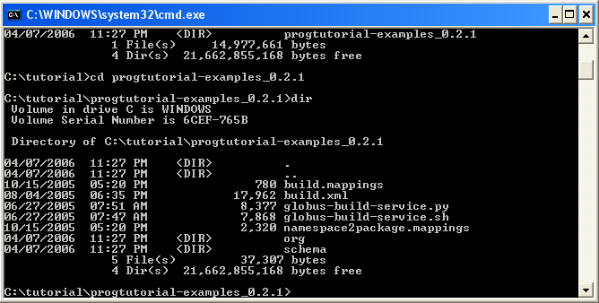

Step 1: Defining the interface in WSDL

Read the Sotomayor tutorial, Section 3.1. This step has already been done for you for the basic Math Service. The WSDL file for the Math Service is found in your C:\tutorial directory. Its location is

C:\tutorial\progtutorial-examples_0.2.1\schema\examples\MathService_instance\Math.wsdl

The directory structure for all of the files that you will need to start is described at
http://gdp.globus.org/gt4-tutorial/singlehtml/progtutorial_0.2.1.html#appendix_dirstruct

Step 2: Implementing the service in Java

Read the Sotomayor tutorial, Section 3.2. This step has also already been done for you for the basic Math Service. The Java file for the Math Service is found in your C:\tutorial directory. Its location is

C:\tutorial\progtutorial-examples_0.2.1\org\globus\examples\services\core\first\impl\MathService.java

Read this example carefully!

Step 3: Configuring the deployment in WSDD (and JNDI)

Read the Sotomayor tutorial, Section 3.3. This step has also already been done for you for the basic Math Service. You will not need to modify any of the files described in this section.

Step 4: Create a GAR file with Ant

You will not use ant directly in this step. Rather, you will use the globus-build-service script as described in Section 3.4.2.

On Unix, follow the steps in the Sotomayor tutorial.

On Windows, from the Exercise Window in the progtutorial-examples_0.2.1 subdirectory run the following commands:

globus-build-service.py first

which is a shortcut for
globus-build-service.py -d org\globus\examples\services\core\first\
-s schema\examples\MathService_instance\Math.wsdl

It should look like this at the end:

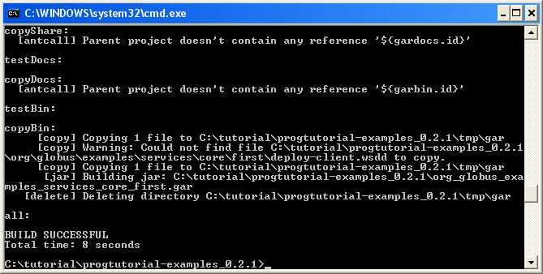

Step 5: Deploy the service into a Web Services container

Now, you should be able to deploy the service.

To deploy the service on Windows type the following all on one line in the Exercise Window from the progtutorial-examples_0.2.1 directory:

%GLOBUS_LOCATION%\bin\globus-deploy-gar org_globus_examples_services_core_first.gar

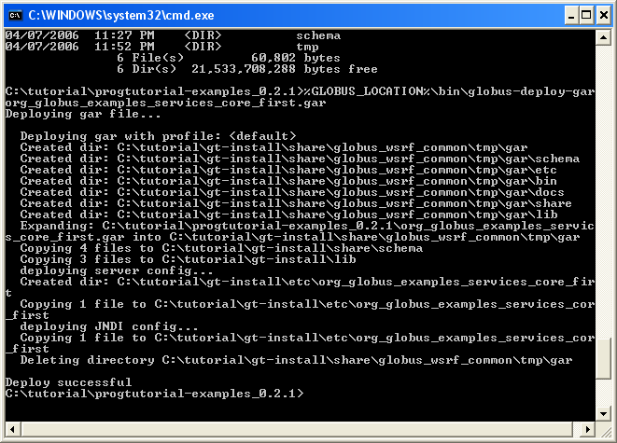

Next, before running the service, in the Exercise window, run the following command:
%GLOBUS_LOCATION%\etc\globus-devel-env.bat

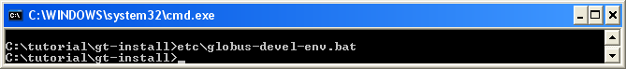

Notice: Windows sometimes have trouble with blank space in the directory name (Program Files, for example). Check your CLASSPATH carefully. If needed, reset your CLASSPATH to some simple directory to prevent possible error.

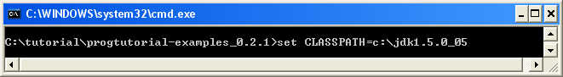

Step 6: Write and compile the client

The client code for the Math Service has already been written for you. Its location is

C:\tutorial\progtutorial-examples_0.2.1\org\globus\examples\clients\MathService_instance\Client.java

To compile the client, in the Exercise window from the progtutorial-examples_0.2.1 directory, type:

$ javac –classpath build\stubs\classes\;%CLASSPATH% org\globus\examples\clients\MathService_instance\Client.java

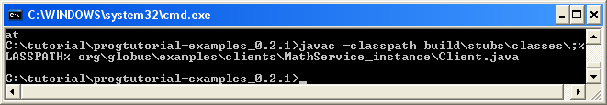

Step 7: Start the container and execute the client

In the GT-Window from the gt-install subdirectory, start the container:

$ bin\globus-start-container -nosec

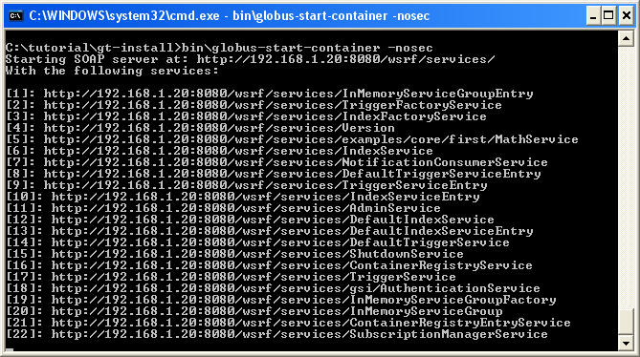

If the service is correctly deployed, we can now run the client in the Exercise Window. Type this all without a carriage return into the window:

$ java -classpath build\stubs\classes\;%CLASSPATH% org.globus.examples.clients.MathService_instance.Client http://127.0.0.1:8080/wsrf/services/examples/core/first/MathService

If all is correct, you should see:

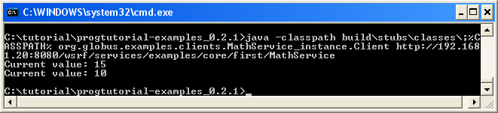

Along the way, it is recommended to follow the tutorial of Sotomayor closely, as although the syntax might be different between Unix and Windows, the idea is the same. To sum up the differences between running Sotomayor tutorial on Unix and Windows:

Using .py and .bat instead of .sh
Environment variables are of the form %<ENV_NAME>% instead of $<ENV_NAME>
Spaces inside directory’s names are to be avoided.
For java and javac calls, the separator for classpath is ; instead of :
\ instead of /, except for the case of URLs.

Step 8: Add functionality to the service

To test your understanding of the concepts, add Multiply functionality to the service. You can add statements to the files that are similar to statements already there. You need to modify only three files:

The interface definition:
C:\tutorial\progtutorial-examples_0.2.1\schema\examples\MathService_instance\Math.wsdl

The service implementation:
C:\tutorial\progtutorial-examples_0.2.1\org\globus\examples\services\core\first\impl\MathService.java

And the client implementation:
C:\tutorial\progtutorial-examples_0.2.1\org\globus\examples\clients\MathService_instance\Client.java
C:\tutorial\progtutorial-examples_0.2.1\org\globus\examples\clients\MathService_instance\ClientAdd.java

Then, go through the steps above to build and deploy the service, compile the client, stop and restart the container, and execute the client.

Enjoy!

